18 Screens — Active Water Escape and Structural Condition
At the Screens, water forms part of the operating process, but the inspection also recorded water escaping beyond the intended screen/chute process route. The operating videos show active spray and runoff, with Screen-REF-017 providing useful visual localization of the external area from which the water appears to emerge. Because the equipment was operating during the inspection, the corresponding internal area could not be safely examined and the component or condition responsible for the escape remains unresolved. A planned shutdown inspection can therefore use the observed external location as a starting point to examine the corresponding internal area, identify the water-loss mechanism and determine the appropriate corrective action. Following any corrective work, the area should then be observed under representative operating conditions to confirm that the water remains within the intended process route.
The same area also shows substantial corrosion and deterioration, together with support members that contain visible cut-outs or notches. These conditions are important in their own right and should be considered separately from the water-loss investigation. The photographs establish the physical deterioration and altered-member geometry, but they do not establish why the openings were made, the remaining capacity of the affected members, or that the observed water escape is the sole cause of the corrosion. A competent structural assessment should therefore establish the role and load path of the affected members, record the relevant dimensions, section loss, cut/notch geometry and connection condition, and determine whether repair, strengthening, replacement or interim controls are required.
Corrosion / Deterioration
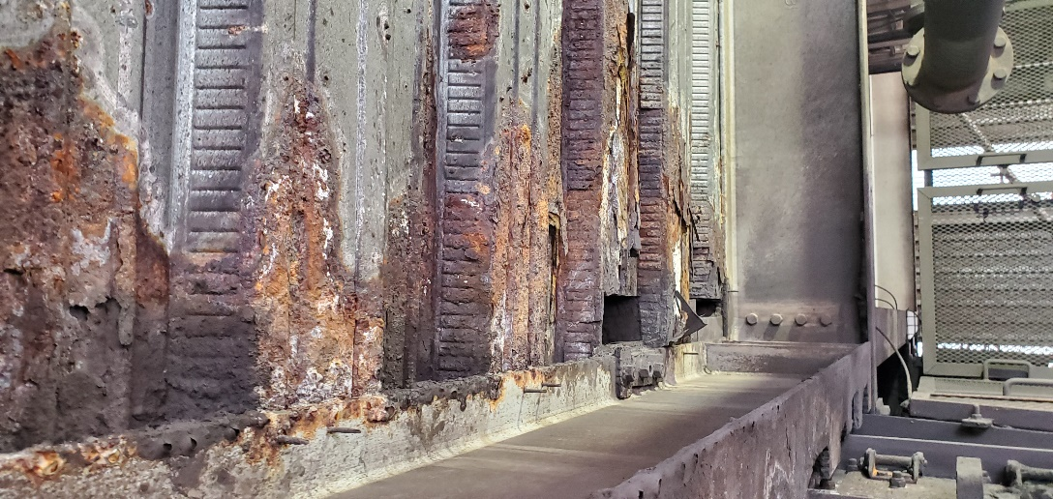  Screen-REF-008 — Wider deterioration view showing the broader extent of corrosion and section degradation within the Screens structure. | 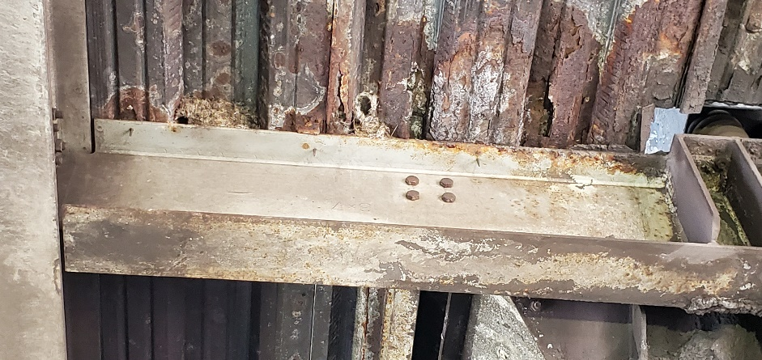 Screen-REF-002 — Close view showing substantial local corrosion and deterioration within the Screens structure. The photograph establishes the visible condition but does not determine remaining structural capacity or its complete cause.
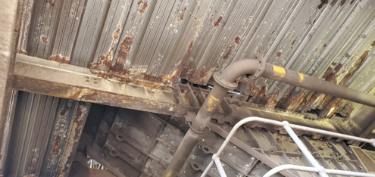
Screen-REF-003 — Wider view of the screen/chute structural area, providing context for the corrosion and deterioration shown more closely in REF-002.

Active Water Escape
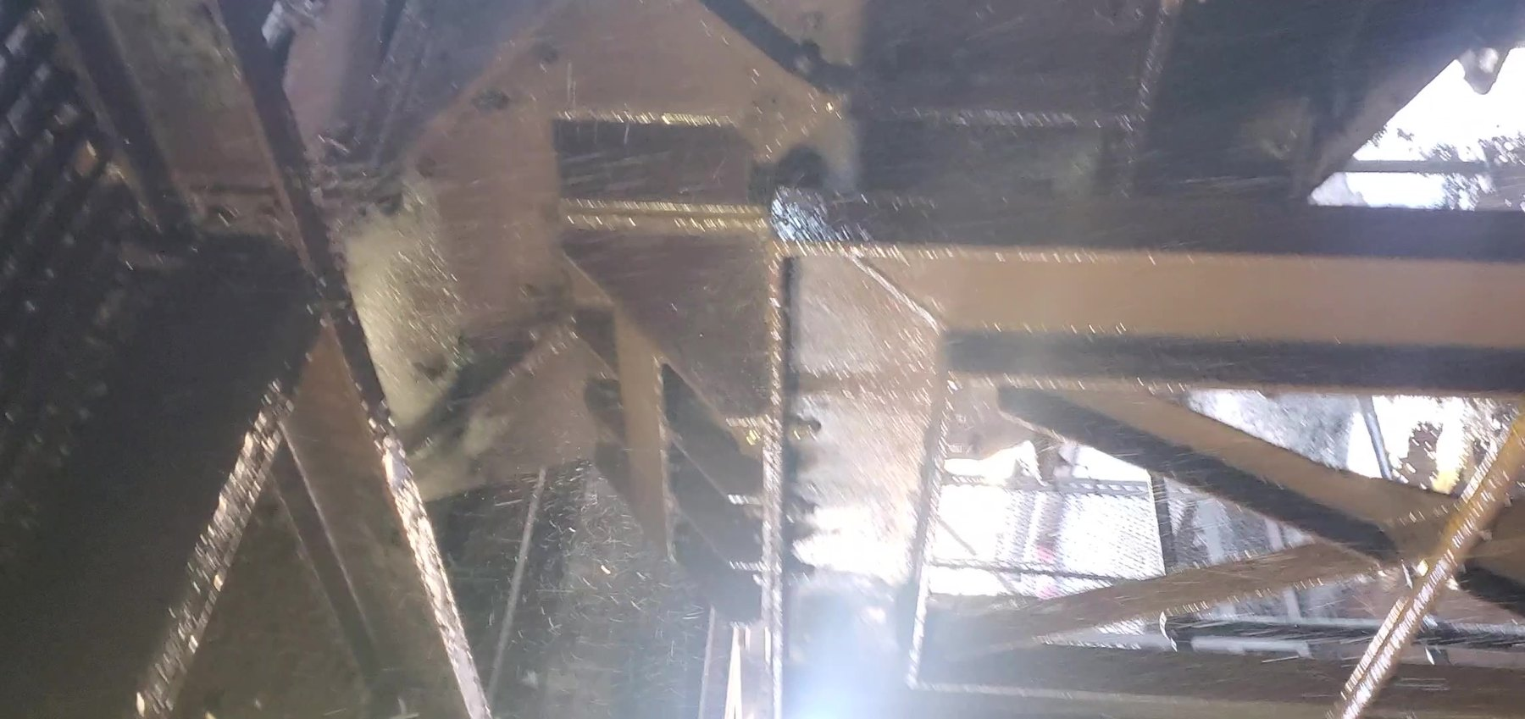  Screen-REF-017 — Representative frame from the operating video showing the external area from which substantial water spray/runoff emerges. The view helps localize the escape point for follow-up shutdown inspection; the internal source remains unresolved. | 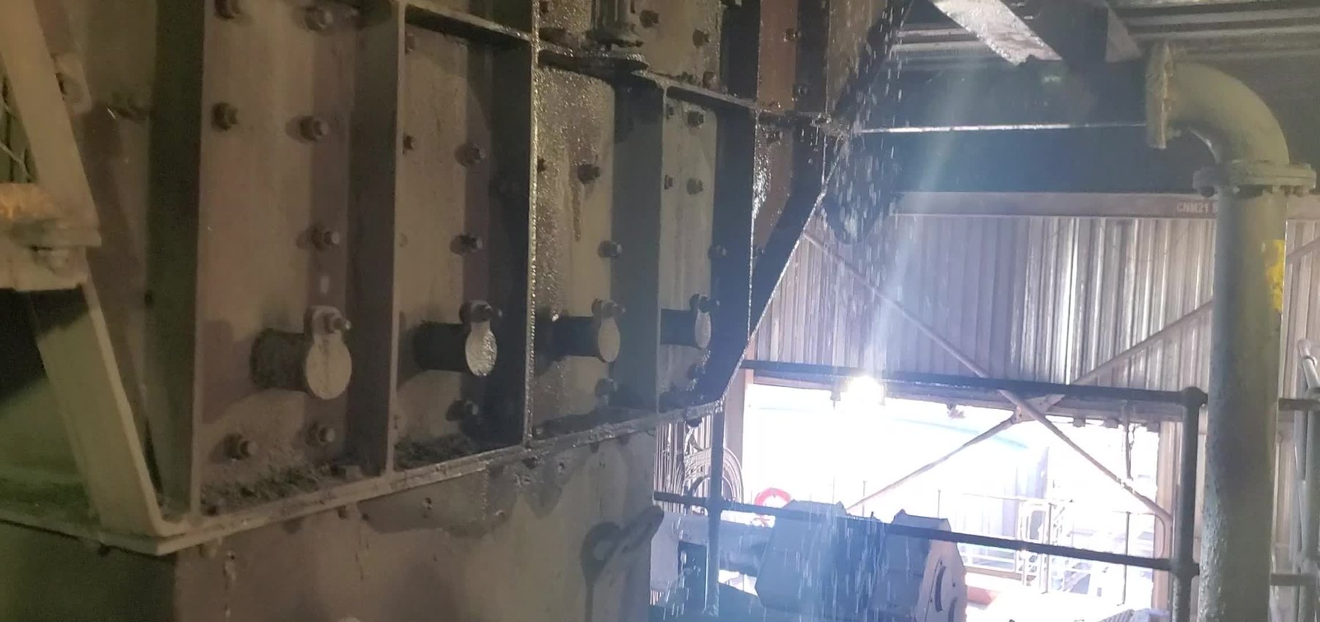  Screen-REF-016 — Representative frame from the operating video showing active process-water spray/escape from the screen/chute area. The video confirms active water loss but does not establish the internal defect or source mechanism.

Support-Member Cut-Outs / Notches
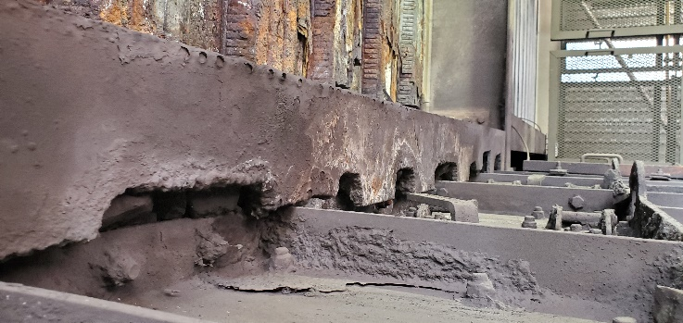  Screen-REF-009 — Wider view showing local cut-outs/notches in the affected support-member arrangement. The reason for the alterations and their effect on remaining structural capacity has not been established. |  | 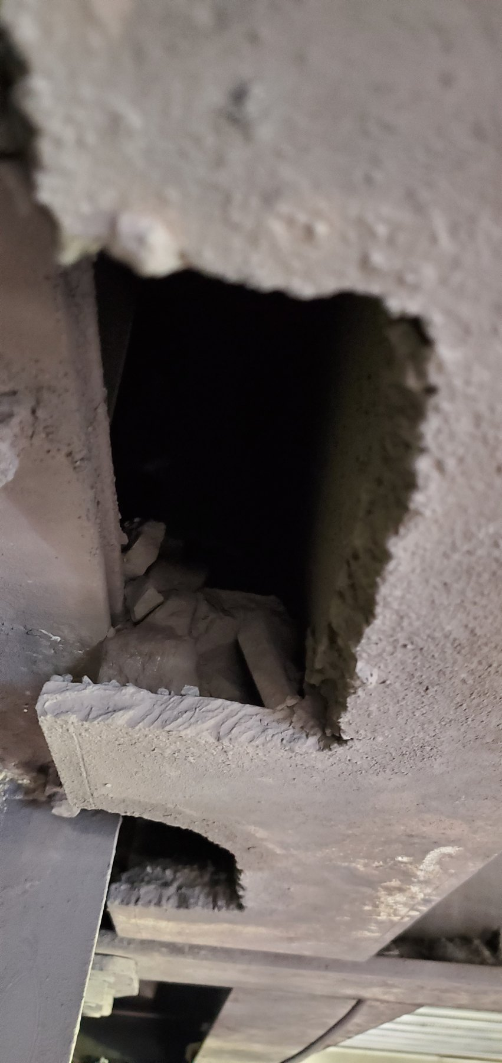  Screen-REF-010 — Close view showing a substantial cut-out in an affected support member. The physical alteration is clearly visible; structural adequacy requires assessment by the responsible structural authority.
OBSERVATION | Active process-water escape is visible in the operating evidence. Substantial corrosion/deterioration and physical cut-outs/notches in support members are also visible within the Screens area. Although these conditions occur within the same operating environment, the available evidence does not establish that they arise from one common cause.
ENGINEERING ASSESSMENT | The operating evidence provides a useful external location from which the water-loss investigation can proceed, but the internal component or condition responsible for the escape remains to be established. Repeated wetting may increase the ongoing exposure of the surrounding structure, although the available evidence does not establish it as the sole cause of the observed corrosion. The support-member cut-outs/notches are physically evident, but their history, structural significance and remaining capacity require competent structural assessment.
RECOMMENDED NEXT ACTION | Use the externally identified water-escape location to guide a planned shutdown inspection of the corresponding internal screen/chute area. Identify the water-loss mechanism and correct the confirmed condition, then re-check the area under representative operating conditions. Separately, complete a competent structural assessment of the corroded and altered support members and implement the resulting repair, strengthening, replacement or interim-control requirements, followed by formal acceptance of the completed structural work.

